Database System Engineering and Distributed Backend Development(25CS1302E)
Practical Week-1

Name : K SRI CHARAN
Roll No. : 2520030093
SEC : 7

Step 1 : Database Setup
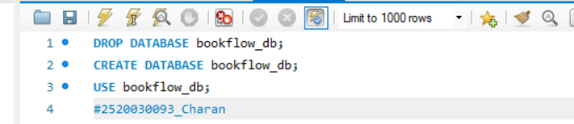
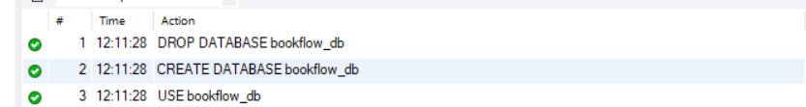

Step 2 : Table Creation
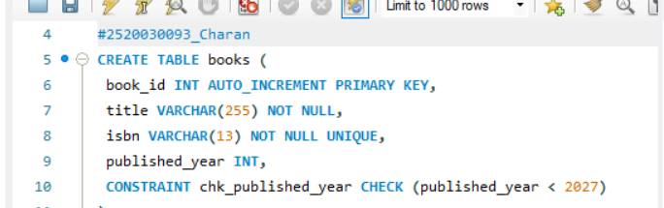
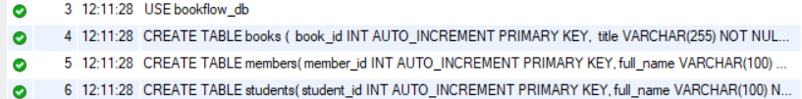
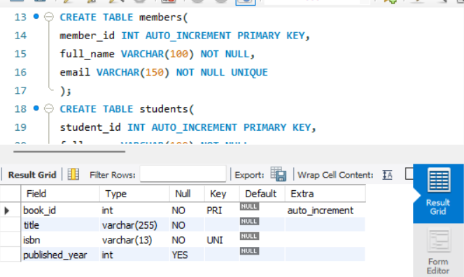

Step 3 : Initial Seeding
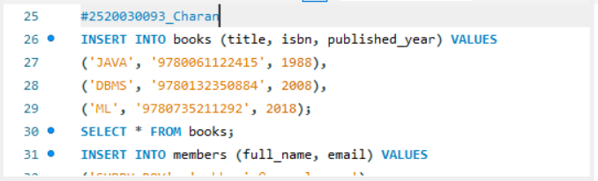

Step 4 : Constraint Tests
